**Ad intel PRINT**

**QUICK START**

**Karel Honzl 2017**



**NÁZEV**

**DOKUMENTU**

Obsah

1. Introduction 3

2. Issues administration 4

2.1. Creating a new issue 4

2.2. Delivery confirmation 7

3. Scanning 8

3.1. Adding a new issue part 8

3.2. Settings before scanning 8

3.3. Scanning 9

3.4. Manual doublepages scanning 10

3.5. Scanning check 10

3.6. Pages rescanning 11

3.7. Finishing the scanning 12

4. Cutting 13

4.1. Loading the issue 13

4.2. Searching the advertisement 15

4.3. Saving the advertisement 16

4.4. Finishing the cutting 17

5. Coding 18

6. Pricing 19

6.1. Browsing for the pricelist diagram 19

6.2. Creating a new pricing diagram 20

6.2.1. Copying a pricelist diagram 20

6.2.2. Building a pricelist diagram 21

6.3. Messages pricing 27

6.3.1. Pricing failed 28

# Introduction

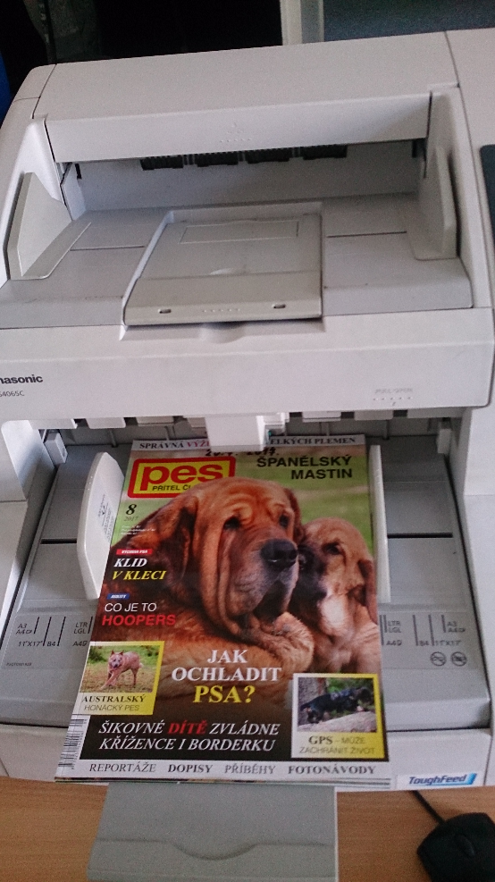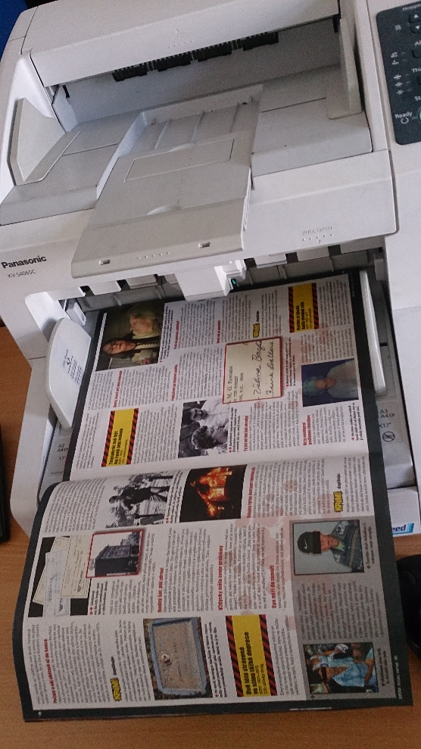This document describes how to process PRINT monitoring. It should be helpful mainly for new employees who never did such a job. The goal is not to explain all the features and advanced functions in all applications but only to provide a quick guide of all steps of the process.

Fig 1: Single page scanning

Fig 2: Double page scanning

Note: This document is based on testing database where the only title “Test” is inserted. In a real production, processes there will be real names of titles available.

# Issues administration

Scanning application is used not only for magazines and newspapers scanning but also for the issue administration. All issues of all titles must be inserted into the system using Scanning application and then every scanning and cutting processes are recorded here.

## Creating a new issue

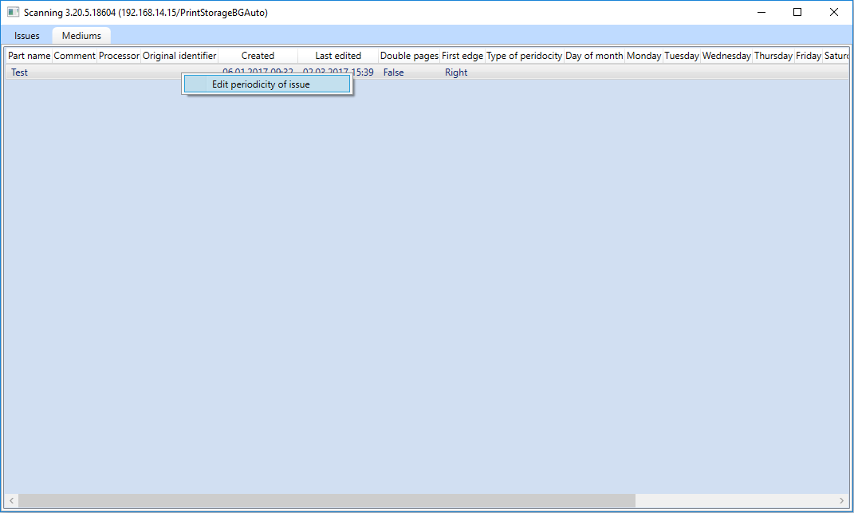There are two possibility to add a new issue into the system by Scanning application. The first possibility is to define automatic issues generation for the particular title. This function is available by right mouse click a medium row of the list in the main Scanning application window in the “Medium” sheet:

Fig 3: Automatic issues generation

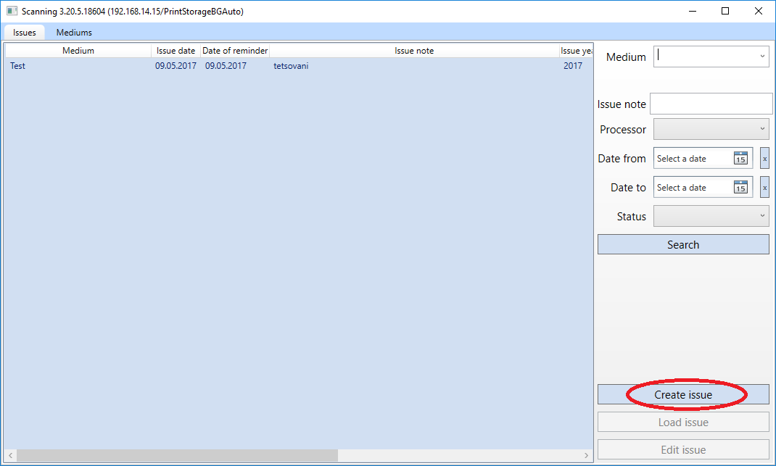Second possibility that is mainly suitable for the testing period is to add a new issue by the “Create issue” button in the main Scanning application window in the “Issues” sheet:

Fig 4: Manual issues creation

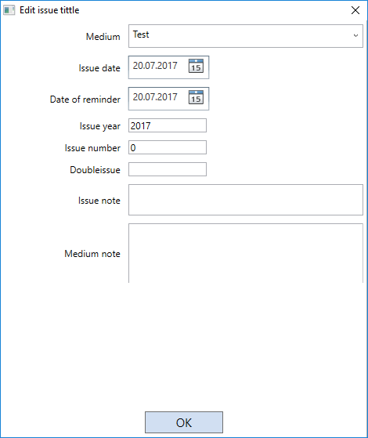Before the new issue is created some information should be filled in following form:

Fig 5: Issue properties

Issue date – it is automatticaly filled by the actual date but operator has to fill the correct issue date!

Date of reminder – not used.

Issue year – filled automaticaly by the actual year but sometimes it must be corrected (ussualy in january).

Issue number – ordinal number (usually given by the publisher), must be filled by operator!

Doubleissue – used only when two or more issues are merged and issued together – in these cases it specifies how many issues are merged (values 2, 3, etc.).

Issue note – any note that will be visible during the next processing steps of the issue (not visible for clients).

Medium note – any note that will be assigned to each issues of this title (not visible for clients).

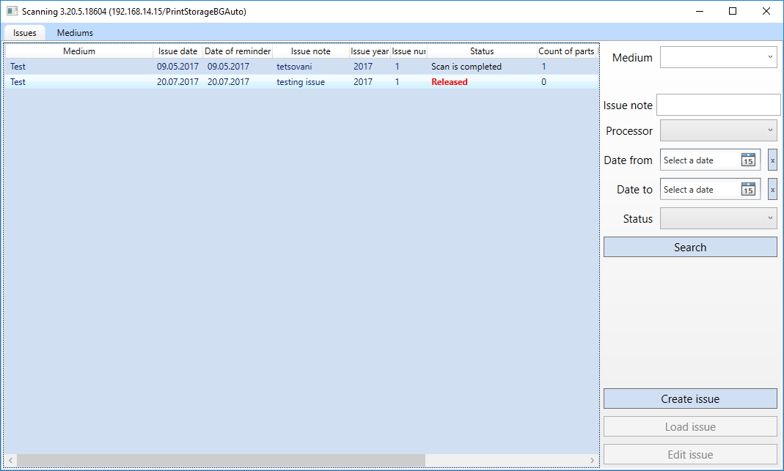When new issue created, it should be visible in the list of issues with the “Released” status:

Fig 6: A new issue created in the list

If it is not visible immediately try to refresh the list by “Search” button on the top right.

## Delivery confirmation

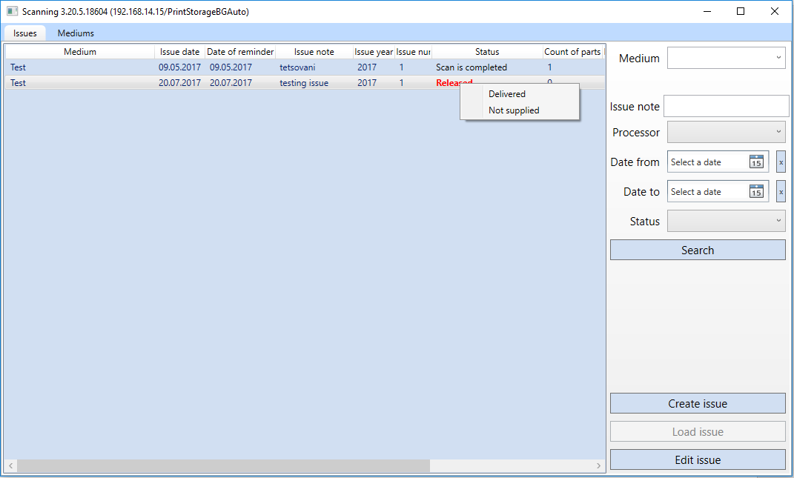If the issue is created manually, it is probably already delivered but if it is generated automatically the system cannot distinguish whether it was already delivered or not. That why the second step is to change the status to “delivered” or “not supplied”. Do it by right mouse click on the issue in the list:

Fig 7: Issue status changing

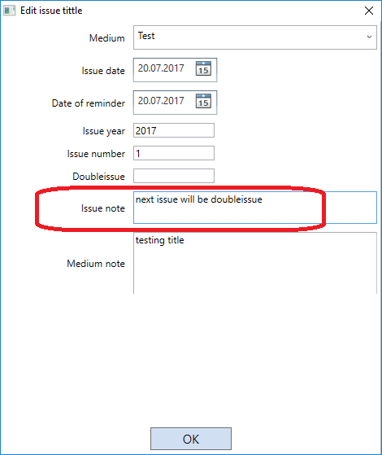If we need to fill “not delivered” there should be some reason. For example some magazines are issued only once instead of twice during a summer holiday. Please write the reason into the “Issue note” filed:

When status changed to “delivered” this window appears:

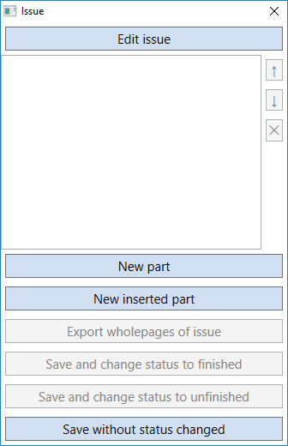

Fig 8: New issue is prepared for scanning

Fig 9: Note should be filled if the issue wasn't delivered.

# Scanning

## Adding a new issue part

Some titles are divided into a few physical parts, e.g.: main part (body) + TV program, catalogue, commercial insertion etc. Before the scanning, we have to add a new part into the issue.

There are two buttons for adding a new issue part:

1. Add a new part

Please use this button to add a new standard part (Body).

1. Add a new inserted part

This button creates inserted part (TV program, catalogue, commercial insertion etc.). Do not use this button - we do not monitor these parts in Bulgaria at this time.

## Settings before scanning

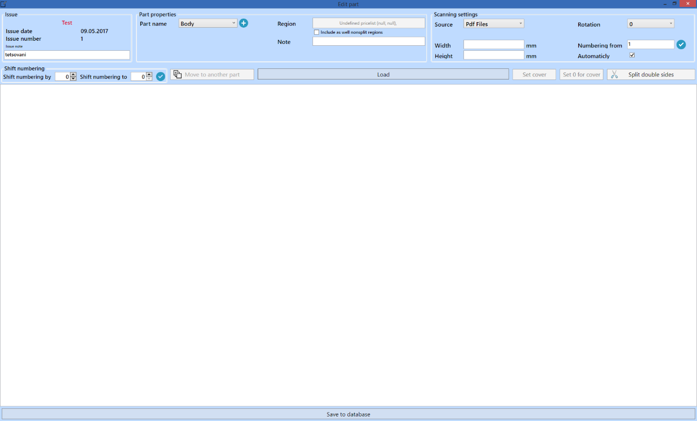“Edit part” window appears when the new part created:

Fig 10: Settings before scanning

There are some basic information about the issue and the name of the part at the top of the window.

Below it, there are important settings for the scanning process:

1. Source – you can choose whether you want scan paper issue or import PDF issue.
2. Rotation [OUT OF ORDER] – this function is not supported by the scanner – but page rotation is available (if necessary) after scanning (see the instruction below) .
3. Width, Height – use manual page size only when scanner is not able to recognize page size correctly!
4. Automaticly – scanners tries automatically recognizing page width and height.
5. Numbering from – the value is usually 1, use different value when issue not scanned at once (e.g.: only pages 1 – 10 were scanned and some problem occurred – then it is not necessary to cancel all the work but it is possible to set value 11 into this filed and continue scanning).

System saves all these settings for this particular title and automatically load them when processing the next issue of the same title again.

## Scanning

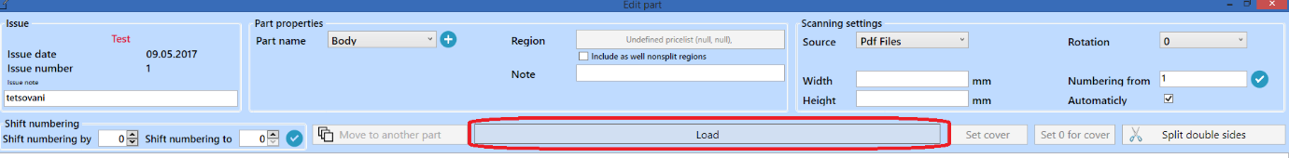It is possible to start scanning by “Load/Scan” button when all settings finished:

Fig 13: Start the scanning

Preview of the scanned pages are visible at the bottom of the window after scanning:

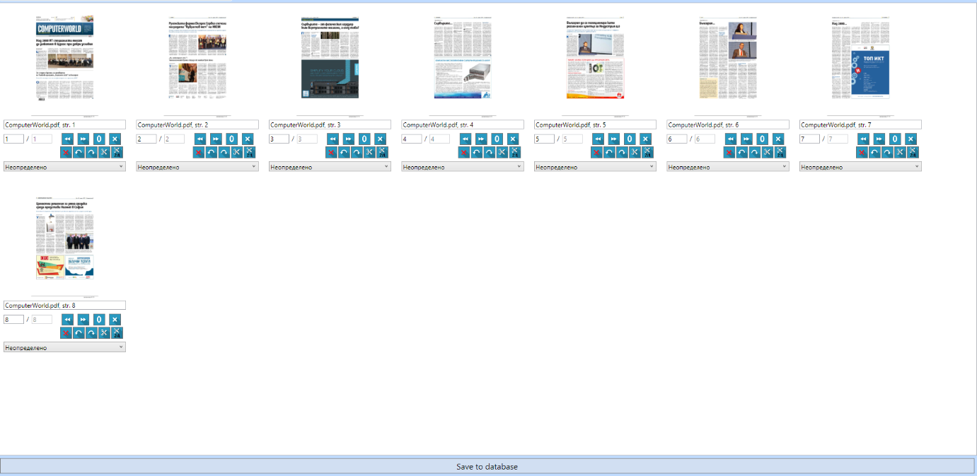

Fig 12: Scanned pages preview

## Manual doublepages scanning

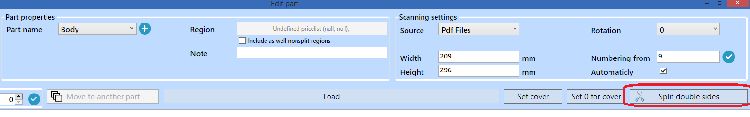If douplepages scanned it is necessary to split them using “Split double sides” button:

Fig 13: Splitting doublepages.

## Scanning check

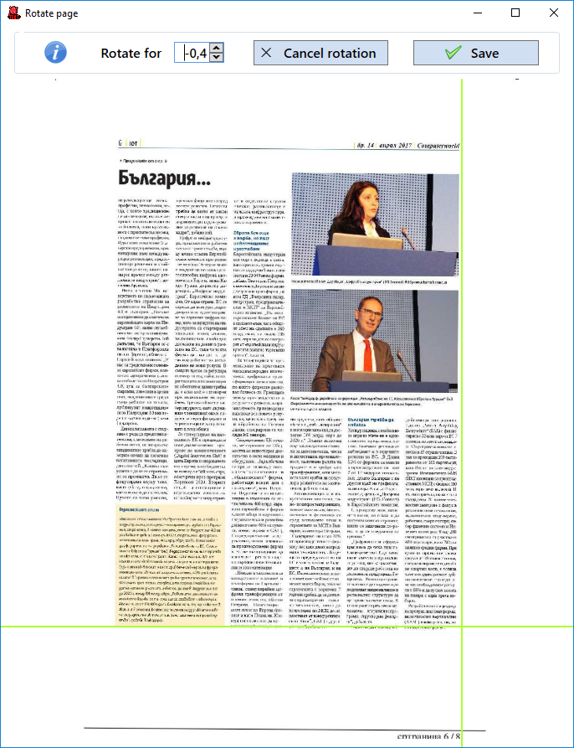Before finishing the scanning, it is necessary to check whether all pages were scanned well. If any of them are not aligned correctly, it must be done manually by rotation function. It is available by double click on the preview of the particular page:

Fig 14: Inclination correction

Use arrow keys (up and down) on keyboard to change incline of the page.

When the page is fine-tuned just click “Save” button to close the window.

## Crop pages loaded from PDF

There is a problem with the pages loaded from PDF provided by Mediazoom. They add margins to PDF files, which cause the wrong adverts Area calculation.

That is why the “Crop” function was implemented in the Scanning application.

**Operator must always use this function when the issue was loaded form PDF.**

See the following instructions:

1. Load all pages form PDF and check the inclination if necessary (see the previous chapter “Scanning check”).
2. 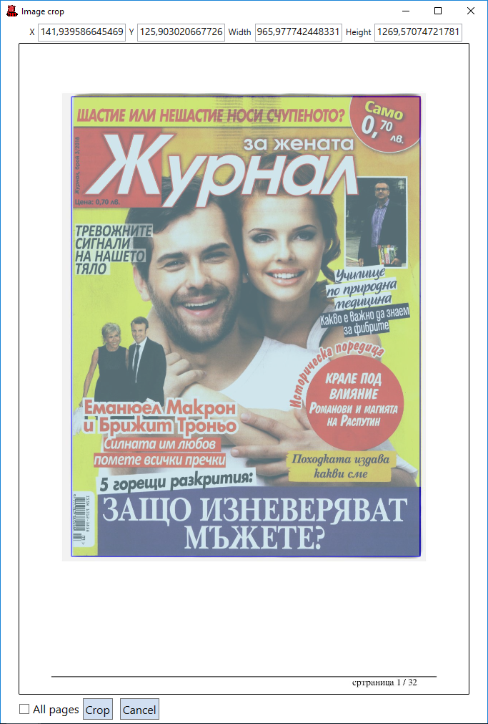Select one page (it is not necessary to select the first one – some another pages could be better if e.g. the first page is white) and click on “Crop” button. New window with the selected page appears. Use mouse (like in Cutting) and select the real area of the page:

Note: You can see some coordinates filled on the top of the window – these coordinates will be saved for each Medium so it would not be necessary to define them for the next issue of the Medium.

**It is necessary operator to check it always! We have no idea if the margins are always the same for all issues of each Medium!**

1. Select “All pages”, click “Crop” button and wait few seconds until all pages are processed.
2. When finished you can double click any of pages and you can see that the margins disappeared and the page size increased.

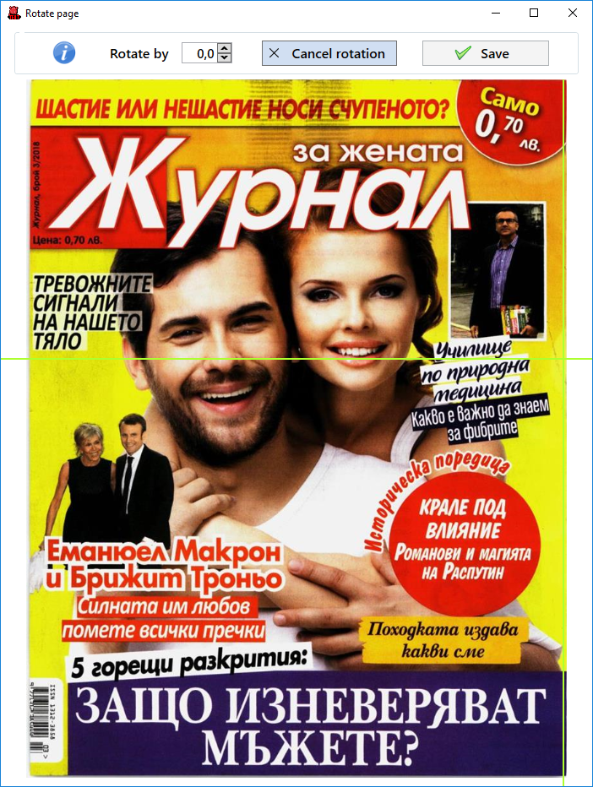

**Check all pages quickly whether they were cropped correctly!**

## Pages rescanning

Sometimes some pages are not scanned precisely and it is necessary to scan them once more. It is not necessary to scan the whole issue again but it is possible rescan only selected pages.

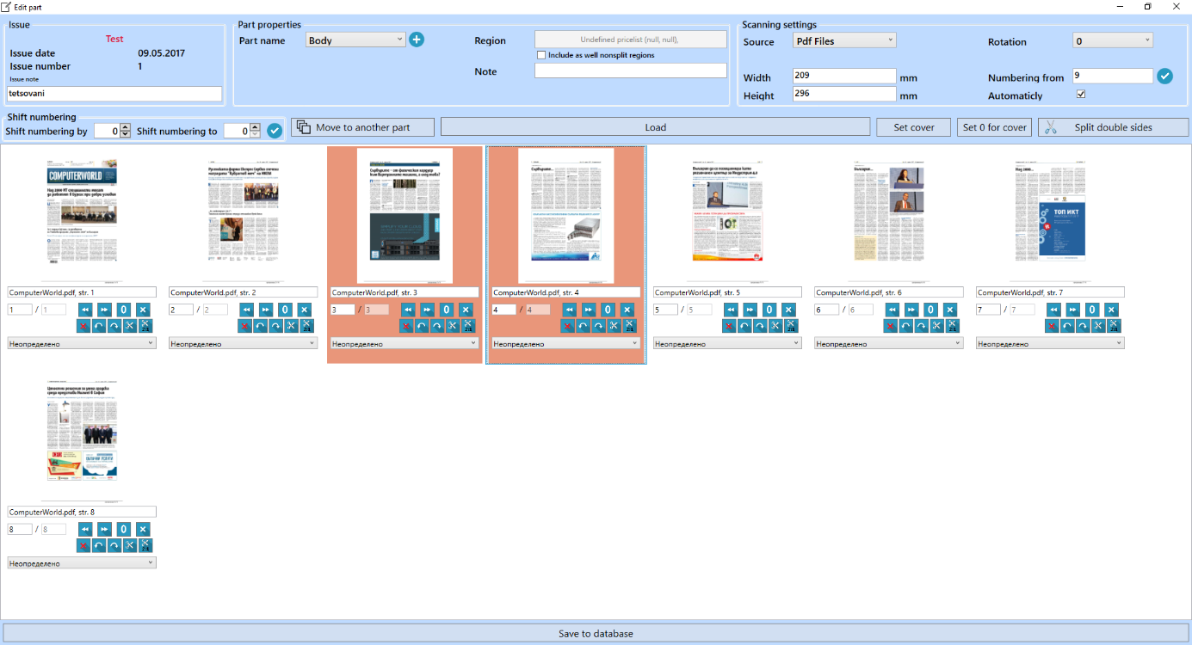Pages which should be rescanned must be selected by the right mouse click:

Then only pages to be rescanned must be inserted into scanner and when “Load/Scan” button clicked these pages would be replaced.

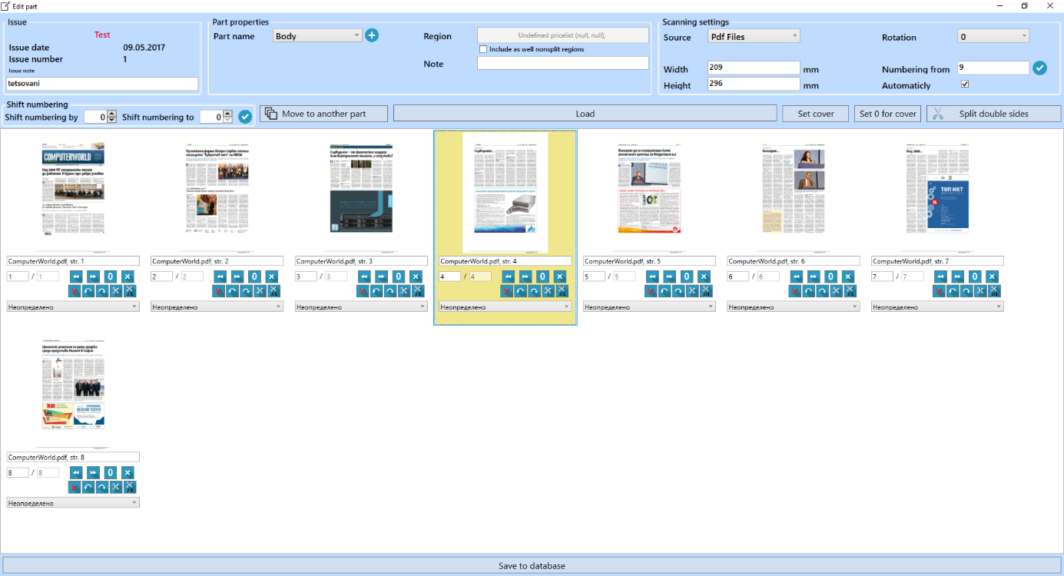There is also possibility to insert new scanned pages into already scanned issue. The first step is to set the place where the scanned pages would be inserted. To do this use middleclick (press mousewheel) to set the “the wall”:

All new scanned pages will be inserted just before this yellow colored page (the wall).

## Finishing the scanning

Close “Edit part” window by “Save to database” button when all pages checked. The “Issue” window appears again with the scanned part of the issue.

To finish the scanning use “Save and change status to finished” button if all scanning is finished or “Save and change status to unfinished” button if the scanning process is not finished yet and it would be necessary to finish it later.

Fig 15: Issue part named "Body" was scanned

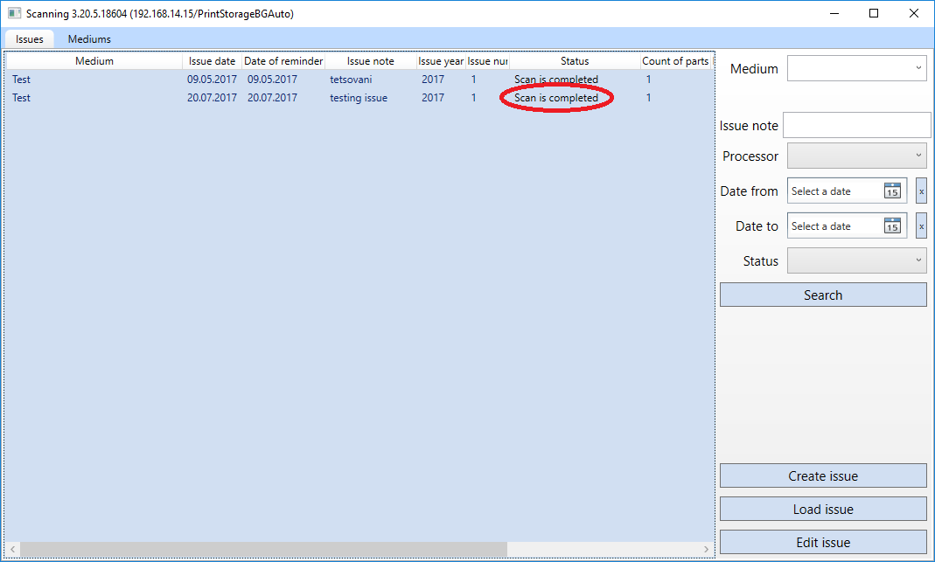Then you should see scanned issue in the list of issues in the main Scanning application window with given status:

Fig 16: Status of the issue is changed to "Scan is completed"

PM starts searching for advertisements when status set to Scan is completed.

Wait for a while and the status will be automatically changed to PM is running and then to PM is finished.

You can load the issue into Cutting application when status is set to PM is finished.

# Cutting

## Loading the issue

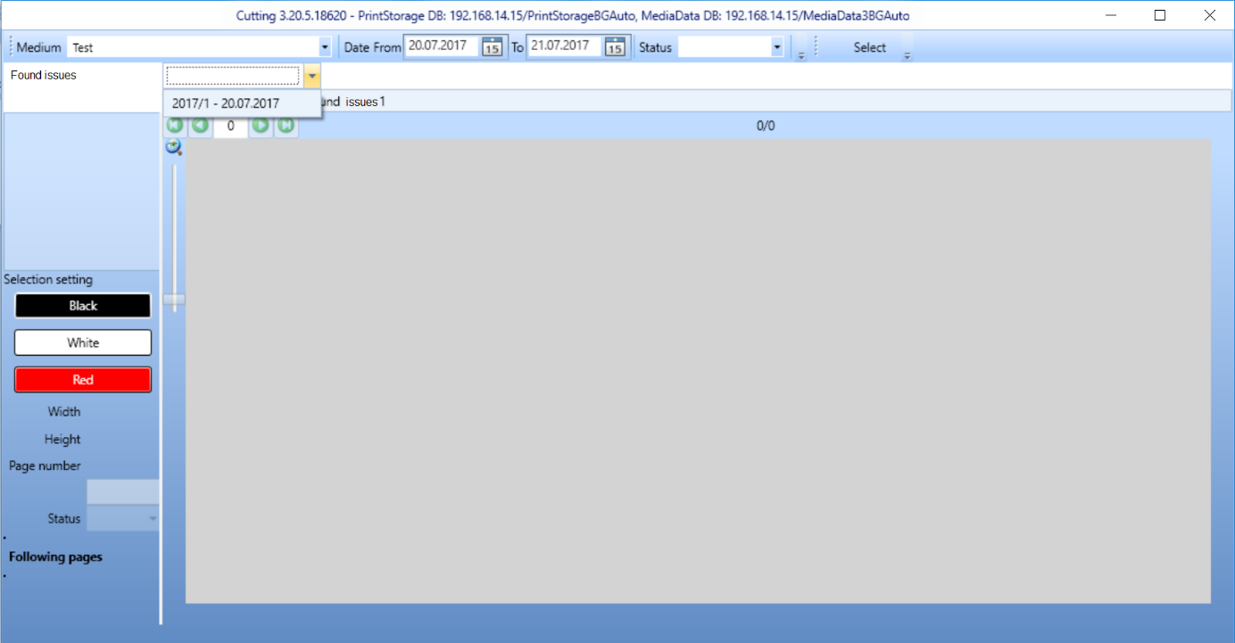The first step is to search the Issue and load it to the Cutting application. When Cutting opened, select the title and date of the issue. You can also specify the status (not necessary). Then click on “Select” button and the found issue is listed in the list next to “Found issues”:

Fig 17: Searching for the issue

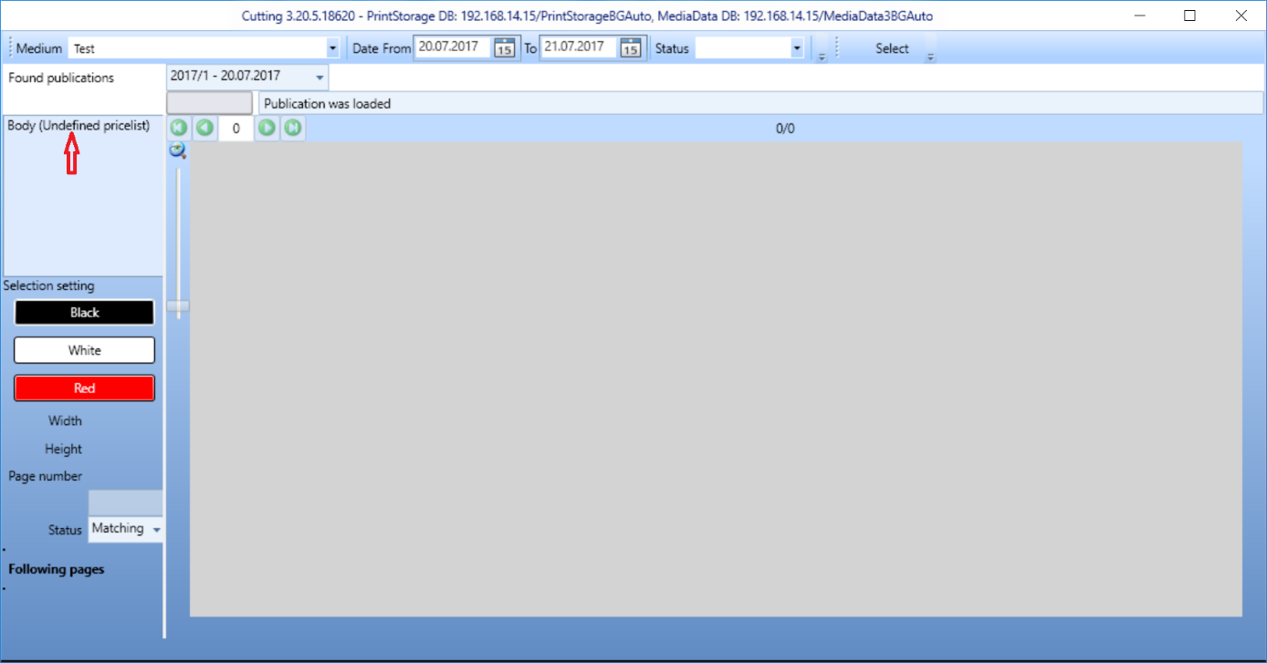Select the issue from the list (there is only one issue found in our example) and all assigned parts will be listed:

Fig 18: All parts of the issue are listed

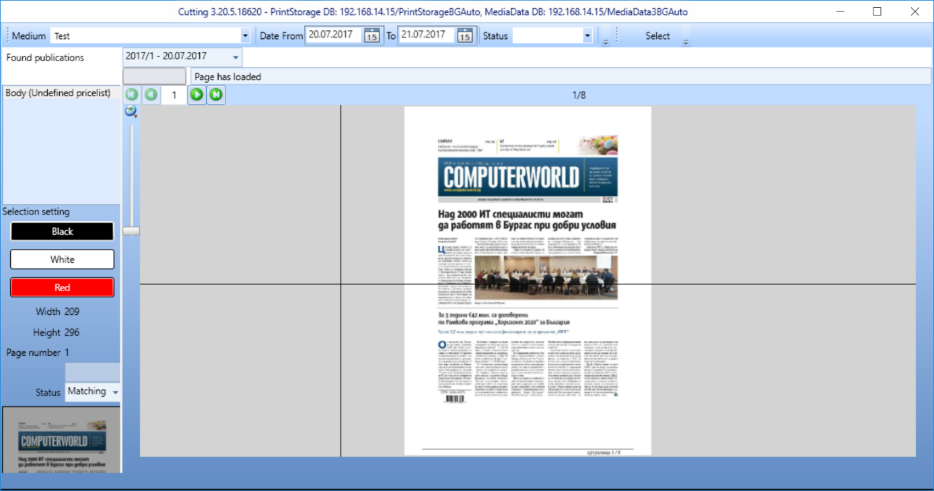Then click on the part you want to cut and it will be loaded:

Fig 19: Selected part is loaded into the Cutting application

## Searching the advertisement

The issue part is now prepared for cutting. Operator has to go through the whole part page by page and search for all advertisements.

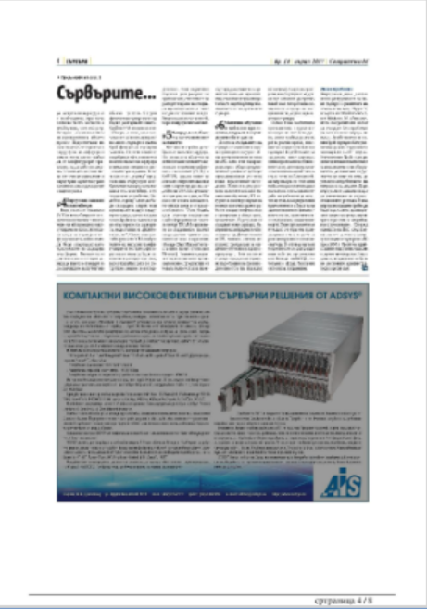If the advertisement is gray colored, it was already automatically cut by the PictureMatching system:

Fig 20: Automatically cut advertisement

It is necessary just to check if it is cut correctly. If not then the operator has to delete the message (right mouse click and select “delete message”) and cut the advertisement again.

If the advertisement is not cut automatically operator has to cut it manually. The first step is to select the rectangle using the cross mouse cursor. For more precious cutting, it is possible to zoom the page using Ctrl + mouse wheel.

Fig 21: Cutting the advertisement

## Saving the advertisement

When the advertisement selected use the right mouse click on it to save it to database:

Fig 22: Saving the advertisement

Note: If the advertisements is not a rectangle and has to be cut in 2 or more rectangles, use “Add current selection to the list of selections”. When all rectangles (the whole advertisement) are added into the list of selection then use “Save all selection to the database”. Use the same for more than one page advertisements.

Fig 23: Save message dialogue

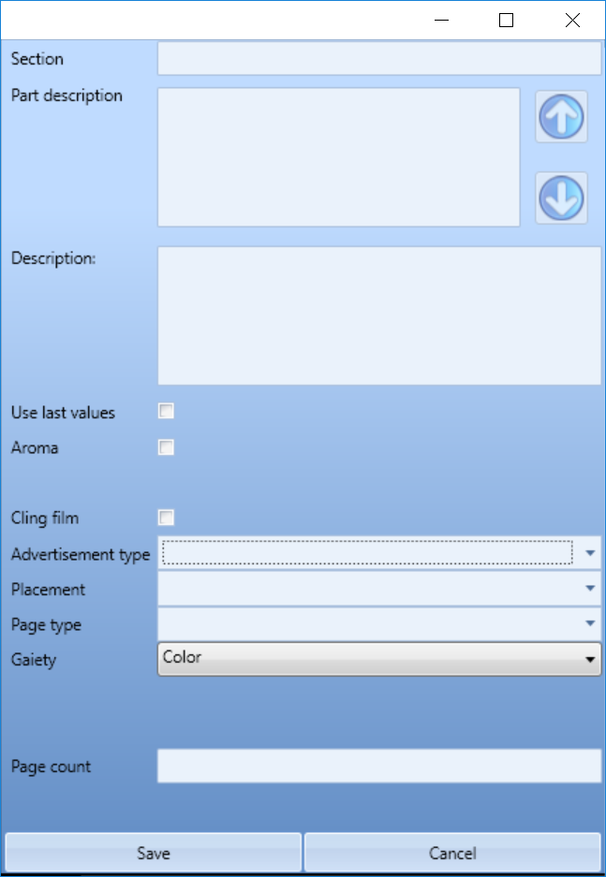Before the saving, there should be some information about the advertisement filled (please fill it according the methodology):

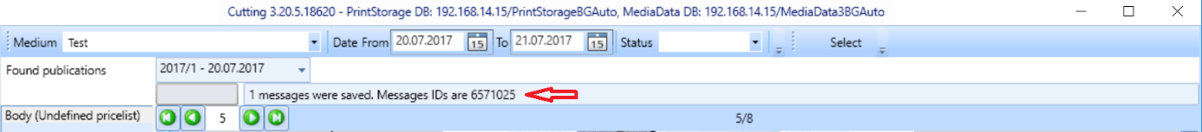When all necessary information filled click “Save” button. Following message should appear:

## Finishing the cutting

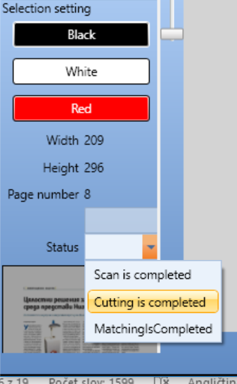When all pages are checked and all advertisements are cut change the status of the issue to “Cutting is completed”:

Fig 24: Issue status change

Then you can close Cutting application and search for the advertisements in the Coding application.

# Coding

Coding process of the Print is very similar to TV coding. Even the same motives are available for TV and Print in Coding application. It is highly recommended to use the same motives for both mediatypes if possible.

The only differences in coding are:

1. Use correct version of Coding application (testing version during the test period):

Fig 25: Test version of Coding

1. Select “Print” mediatype when searching for mediamessages in Coding application:

Fig 26: Select "Print" mediatype

1. 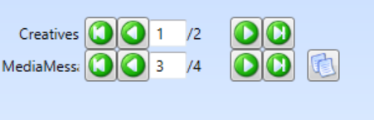There can be more than one creative assigned to one message (e.g. doublepage ads):

Fig 27: Two creatives for one message

1. 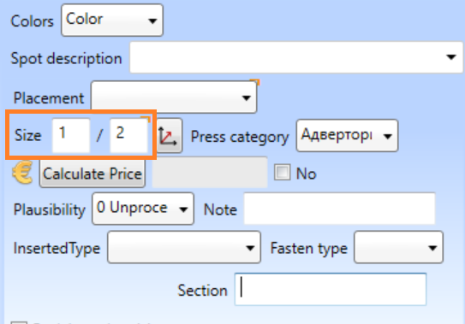Always check the size of an advertisement! It is calculated automatically and there can be potentially some problems (the size is very important for pricing):

Fig 28: Size of the creative

1. There are some specific fields for press to be coded: Colors, Placement and Press category. Some of them should be filled in Cutting but it is good to check them again in Coding.
2. You can use F11 and F12 kays to zoom the creative or the page to full screen.
3. There is no time specification for press messages. There is only the date and the value of time is always 00:00:00.

# Pricing

## Browsing for the pricelist diagram

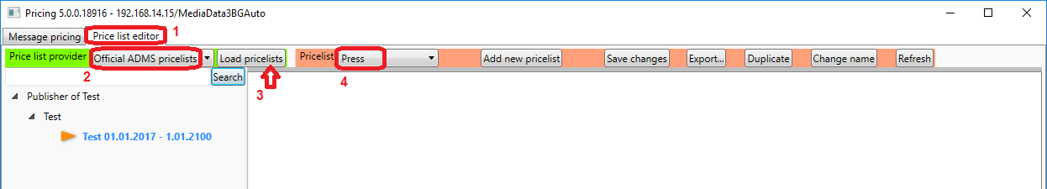When Pricing application opened switch to “Price list editor” window. Then choose “Official ADMS pricelists” pricelist provider, click “Load pricelists” and select “Press” pricelist:

Fig 29: Pricelist diagram searching

Now you can see all pricelists groups already inserted in the left panel and you can browse all subfolders and pricelists. In the picture above, you can see the group named “Publisher of Test”, subfolder “Test” and a pricelist of the “Test” title for the period from 1.1.2017 to 1.1.2100.

We highly recommend to use the same structure of pricelists (Publisher name, Medium name, Particular pricelists with dates of validity).

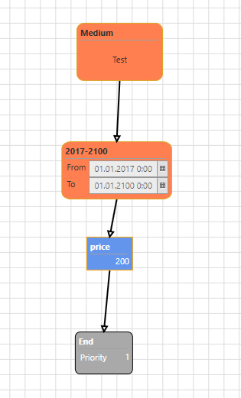When click on orange arrow next to pricelist name the pricelist diagram is loaded:

Fig 30: Example of pricelist diagram

This pricelist diagram is just an example but it works perfectly. In the first step, we filter only messages from the “Test” title. In second step, we check whether the message is from the period of pricelist validity. If both of these two conditions are met then the price of the message is set to 200 BGN and the pricing finishes.

## Creating a new pricing diagram

### Copying a pricelist diagram

There were very simple pricelist diagram in the example above. Let’s imagine that this is a real pricelist but the publisher change it in the middle of the year. The price for the first part of the year is 200BGN but the price for the second half of the year is 220BGN. How to change the pricelist?

1. 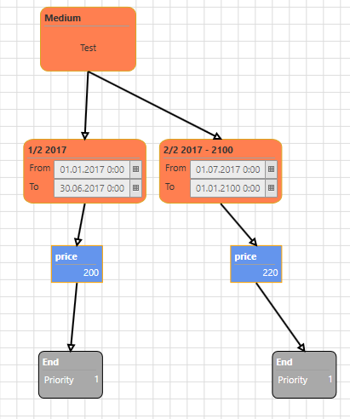We can copy the rectangles of validity, price and finish (using ctrl+c and ctrl+v) then change values in validity rectangles and in the copy of price rectangle. Expanded diagram will look like this:

Note: Please see changed values in validity rectangles and price rectangle.

This type of diagram extension works perfectly but the problem is that the real pricelist diagrams are usually much more complicated and if we will just expand one diagram each time when pricelist changes it would became very incomprehensible soon.

Fig 31: Expanded diagram (not recommended)

1. 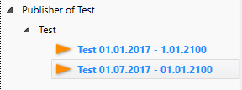Much better way is to create a new pricelist and copy and change old diagram into it. The first step is to create a new pricelist. Use “Add” button at the left bottom corner of the window and fill the name of the pricelist diagram (e.g. Test 01.07.2017 - 01.01.2100). The new item in the list of pricelists should be created:

Fig 32: New pricelist diagram created

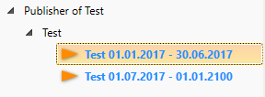We have also to change the name of old pricelists diagram. Double click name (Test 01.01.2017 - 1.01.2100) and change it (e.g. Test 01.01.2017 - 30.06.2017). It should look like this (there is no periods overlap anymore):

Fig 33: Name of old diagram changed

The next step is to copy old pricelist to new one. Load old pricelist diagram (by clicking the orange arrow) then click somewhere into the working area (to activate it) and select all (using ctrl+a) then use ctrl+c.

Then load new pricelist diagram (by clicking the orange arrow) then click somewhere into the working area (to activate it) and use ctrl+v. The whole diagram should be copied.

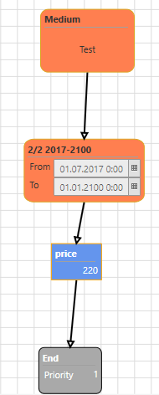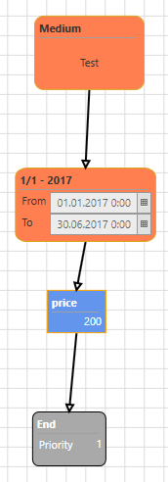Finally, it is necessary to change the price in a new diagram and dates of validity in both diagrams (use double click on the values to change them). You should also change the names of validity rectangles. We recommend to use custom names of rectangles. It is more easy to find the problem when the pricing stop working then. The final pricelist diagrams should look like this:

Fig 34: New diagram (pricelist from 1.7.2017)

Fig 35: Old diagram (pricelist for 1st half of 2017)

### Building a pricelist diagram

There were described how to copy a whole diagram or a part of diagram to some another pricelist. But what if we want to change it or create the different diagram?

There are few steps how to prepare the pricelist diagram containing some other functions in the following example.

Example: Let’s imagine that there are more complicated changes in pricelist of “Test” title from 1.7.2017. Publisher set the prices for particular advertisements sizes in this table:

|  |  |
| --- | --- |
| 2/1 | 1600 |
| 1/1 | 1200 |
| 1/2 | 900 |
| 1/3 | 700 |
| 1/3 | 400 |

And the price for classifieds are calculated by the millimeters of column. The price for 1 mm is 5 BGN.

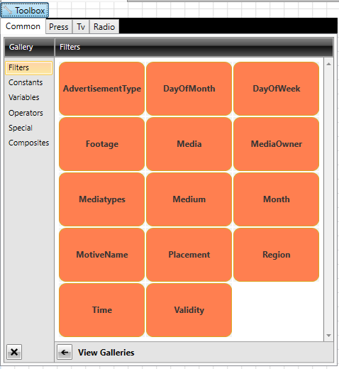The first step is to filter classifieds. We have to load “Test 01.07.2017 - 01.01.2100” pricelist and click on “Toolbox” button at the top left corner. Then select “Common” tab and “Filters”. We can see this menu:

Fig 36: Searching for Placement filter

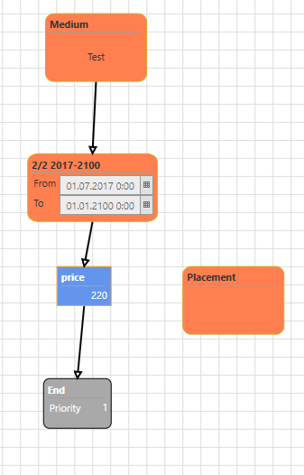We want to use “Placement” rectangle. It is very easy to drug it and drop in working area of the pricelist diagram:

Fig 37: Placement filter dropped into the diagram

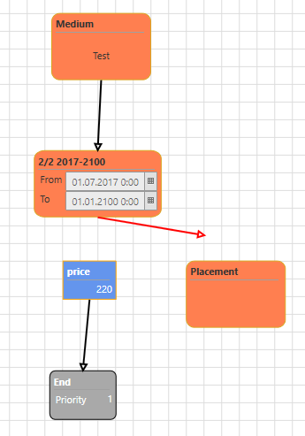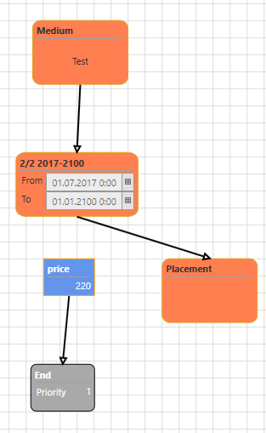Now we can reconnect arrow lined from validity to price. To do it just click on arrow then drug the beginning of the arrow and move it to Placement rectangle (drop it precisely at any of small circles at the edges of the rectangle). If the arrow connected correctly it is black colored, otherwise it is red!

Fig 38: Incorrect connection

Fig 39: Correct connection

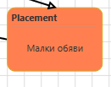The next step is to edit the Placement filter. Double click it and change the value to “Малки обяви” (classifieds):

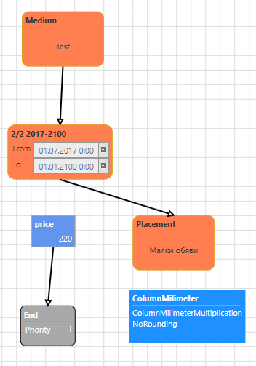Now we can add a new rectangle named ColumnMilimeter. You can find it in “Toolbox”, “Press” tab, “Operators”:

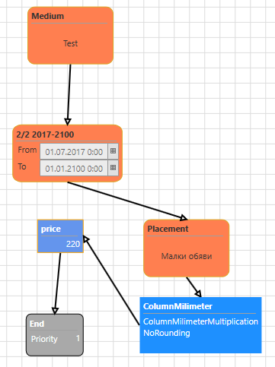Then we have to connect Placement to ColumnMilimeter and ColumnMillimeter to Price. Click on Placement rectangle and small circles should appear. Drag one of them and drop it on ColumnMilimeter rectangle (at one of the small rectangles again). Then do the same to connect ColumnMilimeter to Price:

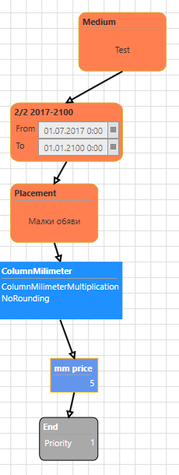The last step for Classifieds is to edit the price. Double click on Price rectangle and set the value to 5. You can also change the name of rectangle to e.g. “mm price”. After some rearrangement of rectangles, it should look like this:

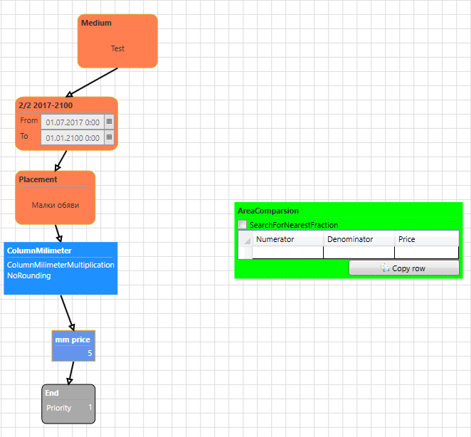Now we need to create a different branch in the diagram for all other placements (not classifieds). The prices definition is based on size (area) of the advertisement. We will use “AreaComparison” rectangle which is located in “Toolbox/Press/Composites”. Drag it and drop into the working area. Green table will appear:

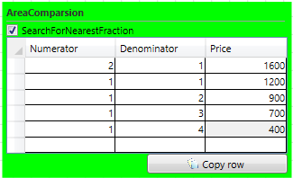Then we need to fill it with the values:

Because there are no any other pricing rule for another sizes of advertisements we need to check “SearchForNearestFraction”. It means it would not calculate the prices just for these 5 particular sizes but it would use the price for the nearest defined size.

Now we can connect Validity rectangle to AreaComparison rectangle and add second “End” rectangle from Toolbox/Common/Special. This “End” rectangle must be connected from AreaComparison.

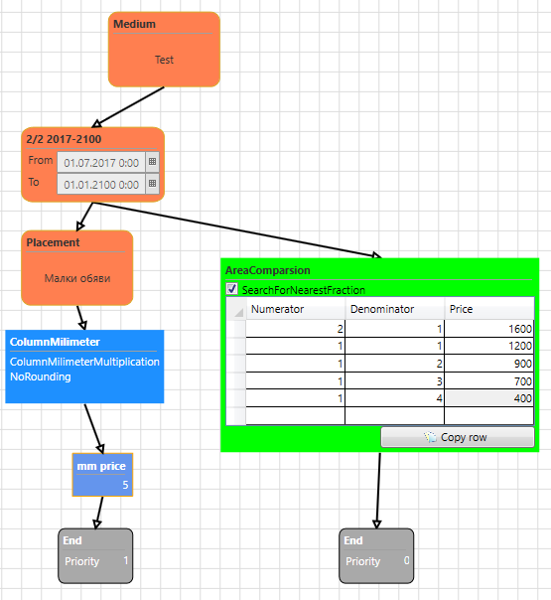The final pricelist diagram should look like this:

Explanation: When system tries to price any message it will do these steps:

1. Is it “Test” title? If yes then continue else cancel.
2. Is it from the period 1.7.2017 – 1.1.2100? If yes then continue else cancel.
3. Now there are two branches. The left branch has higher priority (defined in “End” rectangle). That is why it tries the left branch first.
4. Is the placement “classified”?
5. If yes then continue:

Calculate the number of column millimeters and multiply it by “mm price” (5BGN). Then finish.

1. else use the right branch:

Search for the size in the AreaComparison table and assign the price. Then finish.

****Do not forget to save the diagram using “Save changes” button:

## Messages pricing

When the pricelists diagrams finished and if we have some messages in the database, we can test the pricing.

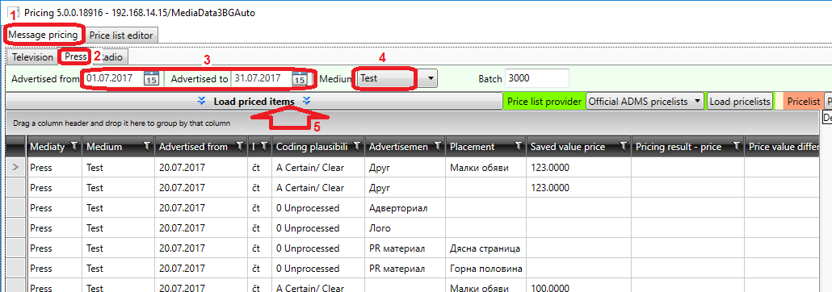Switch to “Message pricing” window in the Pricing application and to “Press” tab. Then set the date range and title name and click “Load priced items” button:

All messages from the selected title and date range will be loaded into the grid. We can see whether these messages were already priced in “Saved value price”.

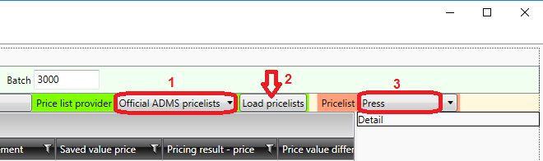Now we have to load the pricelist. Select “Official ADMS procelists” in Price list provider and click “Load pricelists”. When loaded select “Press” in Pricelist field:

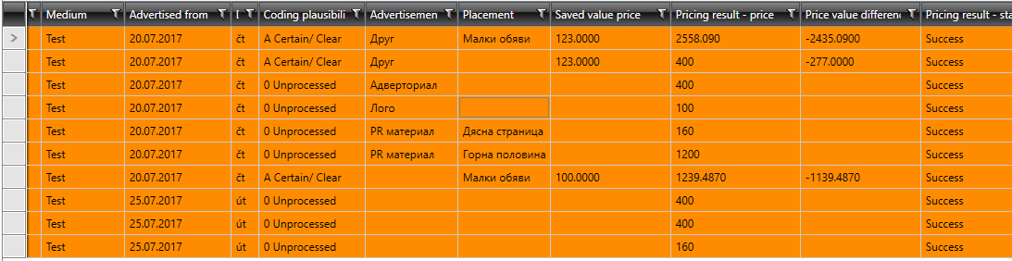The application is prepared for pricing. We can select only a few rows in the grid to calculate the price just for those rows (messages) or we can select all rows (ctrl+a) and calculate price for all messages. To run pricing just click “Calculate” button:

There should be “Success” value in “Pricing result – state” column in all rows after calculation.

Calculated prices are filled in “Pricing result – price” column. You can see the differences comparing to prices already saved in the database in “Price value differences” column.

If the prices are ok don’t forget to save them into database using “Confirm” button:

### Pricing failed

When the pricing failed for any rows, it is possible to track the pricing process step by step to search the problem. In our case all messages were priced successfully but we can track the pricing process anyway.

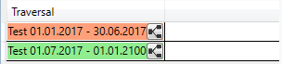If you select the row (message) which you want to analyze you can see the tracking of the pricing process at the bottom right area of pricing application. There are two pricelists in our case. One of them is red and the second is green:

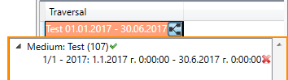You can probably very quickly understand it. The first pricelist failed and the second one succeeded. You can see why it failed if you click on the small grey button next to the red pricelist. Medium was ok but the date of message didn’t meet the validity period. The pricing process canceled and continued with second pricelist diagram.

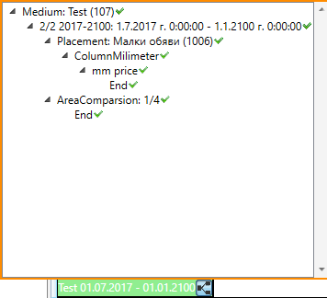Now we can click on small grey button next to green pricelist and we can see all the steps in this pricelist:

* Medium is “Test”
* Validity period is ok
* Placement is “Classified”
* So the price equals ColumnMilimeters multiplied mm price (5BGN).
* Finished successfully.

Note: You can see it successfully finished also through the “AreaComparison” branch but the first branch have higher priority so the price is calculated due to “Classified” branch.